Task 1
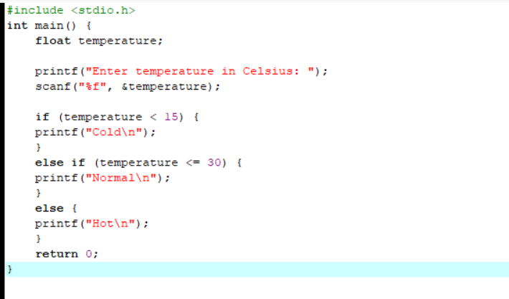
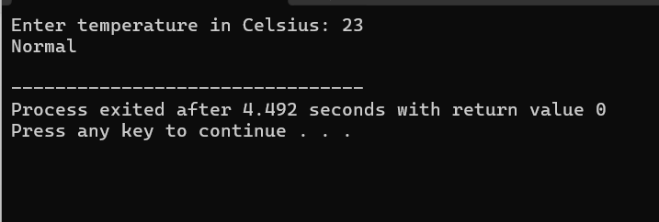

Task 2
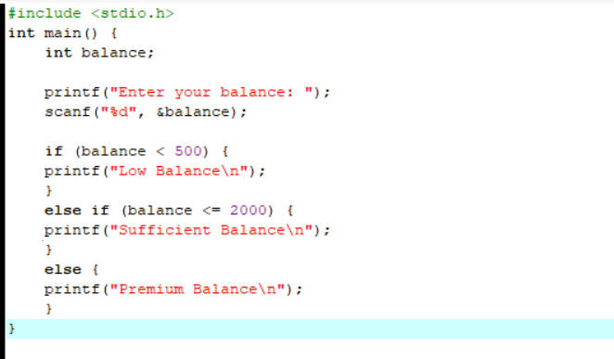
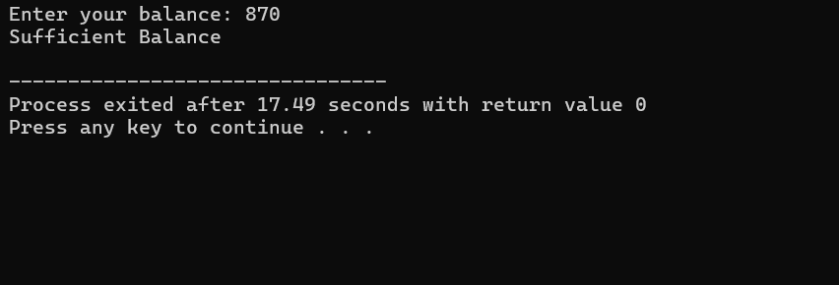

Task 3
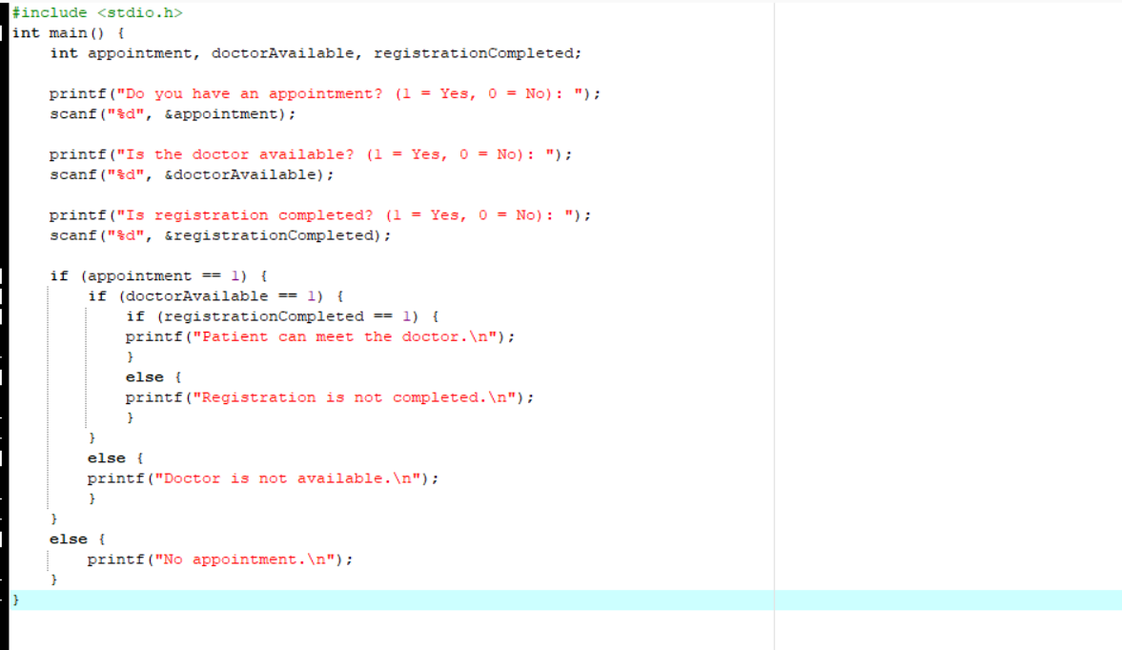
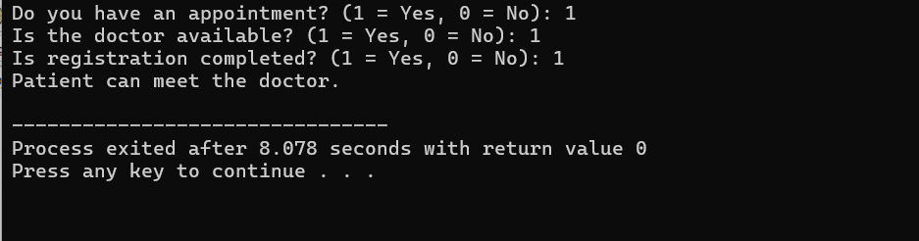

Task 4
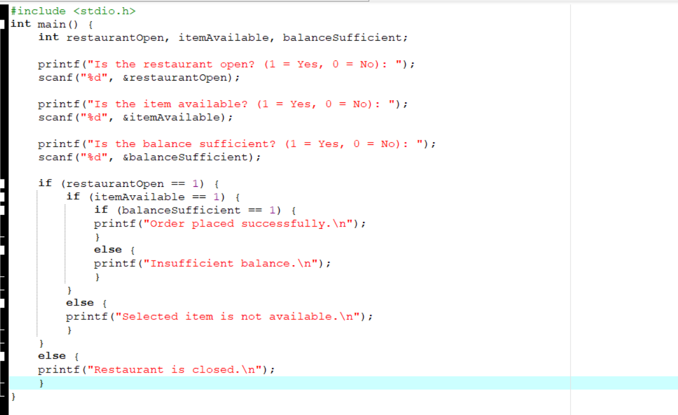
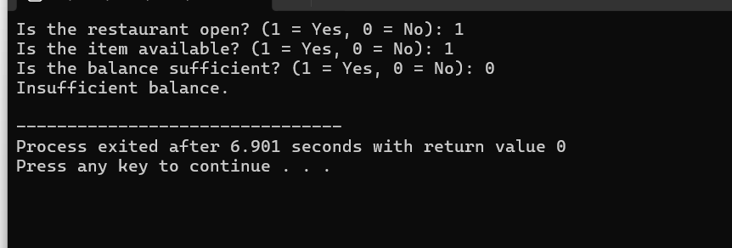

Task 5
#include <stdio.h>

int main() {
int operation, account;

printf("ATM Menu:\n");
printf("1. Balance Inquiry\n");
printf("2. Cash Withdrawal\n");
printf("3. Cash Deposit\n");
printf("4. PIN Change\n");

printf("Enter your choice: ");
scanf("%d", &operation);

switch (operation) {

case 1:
printf("Balance Inquiry selected.\n");

printf("Account Type:\n");
printf("1. Savings Account\n");
printf("2. Current Account\n");
printf("Enter account choice: ");
scanf("%d", &account);

switch (account) {
case 1:
printf("Balance Inquiry - Savings Account\n");
break;

case 2:
printf("Balance Inquiry - Current Account\n");
break;

default:
printf("Invalid account choice.\n");
}
break;

case 2:
printf("Cash Withdrawal selected.\n");

printf("Account Type:\n");
printf("1. Savings Account\n");
printf("2. Current Account\n");
printf("Enter account choice: ");
scanf("%d", &account);

switch (account) {
case 1:
printf("Cash Withdrawal - Savings Account\n");
break;

case 2:
printf("Cash Withdrawal - Current Account\n");
break;

default:
printf("Invalid account choice.\n");
}
break;

case 3:
printf("Cash Deposit selected.\n");

printf("Account Type:\n");
printf("1. Savings Account\n");
printf("2. Current Account\n");
printf("Enter account choice: ");
scanf("%d", &account);

switch (account) {
case 1:
printf("Cash Deposit - Savings Account\n");
break;

case 2:
printf("Cash Deposit - Current Account\n");
break;

default:
printf("Invalid account choice.\n");
}
break;

case 4:
printf("PIN Change selected.\n");

printf("Account Type:\n");
printf("1. Savings Account\n");
printf("2. Current Account\n");
printf("Enter account choice: ");
scanf("%d", &account);

switch (account) {
case 1:
printf("PIN Change - Savings Account\n");
break;

case 2:
printf("PIN Change - Current Account\n");
break;

default:
printf("Invalid account choice.\n");
}
break;

default:
printf("Invalid operation choice.\n");
}

return 0;
}
